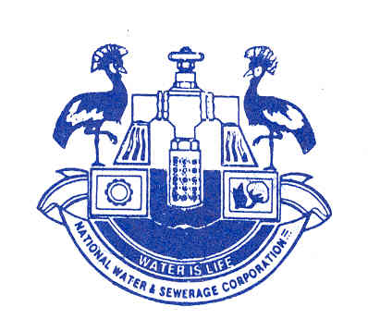
NATIONALWATER AND SEWERAGE CORPORATION

ADDENDUM NO. 1
UNDER PROCUREMENT REFERENCE NOS: NWSC-HQ/SUPLS/22-23/180047 AND NWSC-HQ/SUPLS/22-23/180048

ADDENDUM TO THE INSTRUCTIONS TO BIDDERS
Following a request raised by some prospective bidders to extend the bid submission deadline for the following procurements to allow for ample time for bid preparation.

Supply of Polymers for water treatment under a framework contract for a period of 18 months under Lot; (Ref: NWSC-HQ/SUPLS/22-23/180047)

Lot 1: Polymers for Bushenyi Water Works

Lot 2: Polymers for Masindi Water Works

Lot 3: Polymers for Mpigi Water Works

Supply of Polymers for water treatment under a framework contract for a period of 18 months under Lot; ((Ref: NWSC-HQ/SUPLS/22-23/180048)

Lot 1: Polymers for Mbarara Water Works

Lot 2: Polymers for Mityna Water Works

Lot 3: Polymers for Fort Portal Water Works

National Water & Sewerage Corporation has amended, Section 2: Bid Data Sheet of the Standard Bidding Document to read as follows;

- ITB 24.1: The deadline for submission of proposals has been extended from February 10, 2023 to March 03, 2023 at 10:30am

- ITB 27.1: The date of proposal opening has been extended from February 10, 2023 to March 03, 2023 at 11:00am

- ITB 20.1: The required bid validity period has been extended from August 8, 2023 to August 28, 2023.

- ITB 21.3: The required Bid Security period has been extended from September 15, 2023 to October 5, 2023

NOTE: All the other contents of the Bidding Document remain the same.

Signature: Name: Nable A. Byaruhanga

Senior Manager Procurement Date: January 23, 2023

