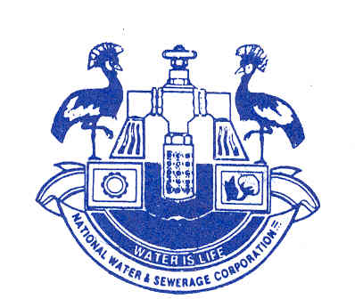

**Standard Invitation to Bidders**

**BID NOTICE UNDER OPEN INTERNATIONAL BIDDING**

**CONSTRUCTION WORKS FOR THE KANUNGU WATER SUPPLY IMPROVEMENT PROJECT**

**Procurement Reference Number: NWSC-HQ/WRKS/24-25/181254**

1. National Water and Sewerage Corporation has allocated funds to be used for the Improvement of Water Supply Services in Kanungu, Kihihi, and the surrounding areas, by upgrading the water supply infrastructure, thereby ensuring water supply reliability.
2. The Entity invites sealed bids from eligible bidders for the provision of the above works.
3. Bidding will be conducted in accordance with the Open International Bidding procedures contained in the Government of Uganda’s Public Procurement and Disposal of Public Assets Act, CAP 205 and Regulations, 2023 and is open to all bidders.
4. Interested eligible bidders may obtain further information and inspect the bidding document at the address given below at 8(a) from 8:00am to 5:00pm on working days.
5. The bidding document which has been prepared in the English languagemay be purchased by interested bidders on the submission of a written application to the address below at 8(b) upon payment of a non-refundable fee of **UGX 200,000 (Uganda Shillings: Two hundred thousand only)***.* The method of payment will be in cash to a Local Bank*.* No liability will be accepted for loss or late delivery.
6. Bids must be delivered to the address below at 8(c) at or before **10:30AM** on **August 12, 2025.** All bids must be accompanied by a bid security of **UGX 100,000,000 (Uganda Shillings: One hundred million only)***.* Bid securities must be valid until **April 30, 2026**. Late bids shall be rejected. Bids will be opened in the presence of the bidders’ representatives who choose to attend at the address below at 8(d) at **11:00AM** on **August 12, 2025**.
7. There shall be a pre-bid meeting/site visit at the **NWSC Kanungu Area Office**, on **July 09, 2025 and July 10, 2025 starting** at **10:00AM.**
8. Bidders should note the following:
9. Documents may be inspected at:

**National Water and Sewerage Corporation**

**Plot No. 18/20, 6th Street, Industrial Area, Kampala**

**P. O. Box 7053 Kampala, Uganda**

**Tel: 256-414-315484/256-414-315801**

**Email: nwscbid@nwscic.co.ug**

1. Documents will be issued from: Same as 8 (a) above
2. Bids must be delivered to:

**National Water and Sewerage Corporation**

**Plot No. 43/49, 6th Street, Industrial Area, Kampala**

**P. O. Box 7053 Kampala, Uganda**

**Tel: 256-313-315864/256-313-315801**

1. Address of bid opening: *Same as 8c above*
2. The Planned Procurement Schedule (subject to changes) is as follows:

| **Activity** | **Date** |
| --- | --- |
| 1. Publish bid notice | **June 24, 2025** |
| 1. Pre-bid meeting/ Site visits where applicable | **July 09, 2025 and July 10, 2025 @ 10:00AM at NWSC Kanungu Area Office** |
| 1. Bid closing date | **August 12, 2025 @ 10:30 AM** |
| 1. Bid opening date | **August 12, 2025 @ 11:00 AM** |
| 1. Evaluation process | **September 02, 2025** |
| 1. Display and communication of best evaluated bidder notice | **September 08, 2025** |
| 1. Contract signature | **After Solicitor General’s Clearance** |

**Accounting Officer**